Soccer rules 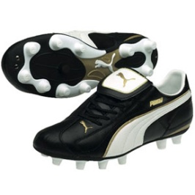
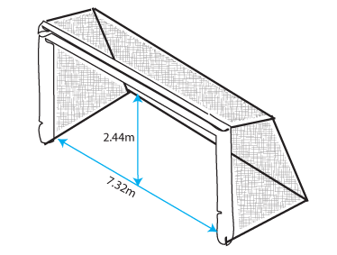
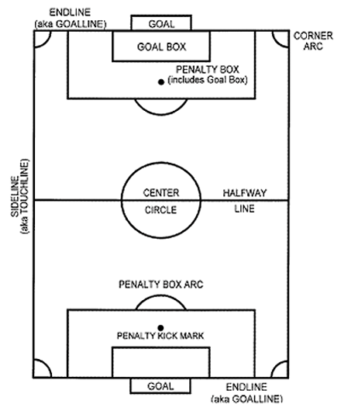
** May not need to be concerned about all rules (offsides, direct/indirect, etc.) or field divisions (penalty box, goalie box, etc.) for an organized and successful pick-up game.
- Necessities: feel free to improvise in terms of equipment if you don’t have these
- Soccer ball
- Goals
- Rectangle boundaries

1. No Hands, please
The rule for a hand ball includes using any part of the body from the tips of the fingers to the shoulder.
The proper way to look at this soccer rule is that a player cannot “handle” the ball. A ball that is kicked and hits a player’s hand or arm is not a hand ball. This means that the referee must use his or her own judgment to some extent in determining whether or not a hand ball is accidental contact or a purposeful attempt to gain an advantage.
Believe it or not, there is also a situation in which the goalie cannot use his/her hands. This is sometimes called the back-pass rule. Goalkeepers cannot pick up a pass that came directly from one of their teammates. In this case, the goalkeeper must use his feet. Infraction of this soccer rule will result in an indirect (cannot be kicked “directly” into the goal – must be passed to another teammate first) kick from the point of the infraction.
2. Throw-ins
A throw-in is taken when the ball crosses out of bounds (“sideline”) and leaves the field.
The two basic soccer rules for a proper throw-in are to have both feet on the ground and to throw the ball with both hands over the head.
3. Corner Kicks & Goal Kicks
A corner kick or goal kick is taken when the ball goes out of bounds across the endline (the end of the field).
If the offensive team kicks it out, play is restarted with a goal kick (change of possession). If the defensive team kicks it out, play is restarted with a corner kick (offense retains possession).
The goal kick is taken from anywhere inside the “goalie box.” It can be taken by any player, not just the goalkeeper.
The corner kick is taken from the corner of the field nearest to where the ball went out of bounds.
FYI: In youth soccer games it is common to see a goal kick retaken (re-tried). This is because the FIFA soccer rules state that the ball is not back “in play” until it leaves the penalty area, the large box outside of the “goal/goalie box”. No one can touch the ball until it leaves the penalty area, and if the ball is not kicked properly to leave the area, the kick must be retaken.
4. Fouls
The common rule of thumb on fouls is “If it looks like a foul, it probably is.”
A player cannot kick, trip, jump at, charge, strike, push, hold, or spit at an opponent.
So what’s the problem?
Soccer can be a physical, contact sport when two opposing players both want the soccer ball.
Bumping or going shoulder-to-shoulder while competing for a ball is not a foul until the hands or elbows come up. This is a bit of a judgment call and not all referees will call it the same way. Some soccer rules are actually not black-and-white.
To prevent argument, the referee is ALWAYS right.
5. Direct and Indirect Free Kicks
The simple difference between the two is this:
On a direct kick you can score by kicking the ball directly into the goal.
On an indirect kick you cannot score. An indirect kick must be touched by another player before it can go into the goal – that is the kicker and a second person.
For an indirect kick, the referee will hold one arm straight up in the air until the second person touches the ball. No arm up, it’s a direct kick.
There are many soccer rules around what causes a direct or indirect kick.
In general, a direct kick comes from a contact foul or hand ball. Everything else is indirect.
6. Penalty Kick
A penalty kick results from a contact foul or hand ball by the defending team within the penalty area – the large box on either end of the field. So it’s a type of direct kick also.
The ball is placed on the penalty spot, 12 yards in front of the center of the goal.
All players must remain outside the penalty area and the penalty arc until the ball is kicked. The goalkeeper must have both feet on the goal line until the ball is kicked.
If after the ball is kicked, it rebounds off of the goal or the keeper and stays on the field, the ball is “live” and anyone can play it.
7. Two-touch Rule
A player cannot touch the ball twice in a row when putting the ball in play. This may occur frequently on kick-offs or direct and indirect kicks. If a player barely hits the ball and decides to take another swipe at it, that is a two-touch.
This also applies to throw-ins. A player cannot throw the ball in and then kick it.
8. Offside
(To be honest with you, this is a hard rule to understand. Don’t get too hung up on it. It can be ignored for Youth Group purposes, as not many people understand this rule, and the game can still be played efficiently.)
An offensive or attacking player can’t be ahead of the ball and involved in the play unless there is a defender between him and the goalkeeper.
Or, in other words, you can’t hang out at the other team’s goal waiting for the ball.
A player, simply said, cannot be offside on a 1) corner kick, 2) goal kick, or 3) throw-in.
It is not an offense for a player to be in an offside position. The player must be involved in active play as determined by the referee to be called offside.
You can’t be offside if you are standing on your half of the field.

